# Project: Detect cyclist in image/video

# 1. Definition

## Overview

Object detection is an important computer vision task that allows a model to classify a label to the identified object and localize it in the given image. I am motivated by the idea that a camera based sensing device can go through the visuals of our physical surroundings and interpret the world like humans do. This has a major impact on how we as society interpret objects, resources and interact with them.

I would like to understand how vision sensing can process the vision signals and derive useful information like label, texture, orientation etc. from it. **I like outdoors and specially bicycling and would like to understand bicyclists on streets.**

Wikipedia describes this task as “***Object detection****is a computer technology related to*[*computer vision*](https://en.wikipedia.org/wiki/Computer_vision)*and*[*image processing*](https://en.wikipedia.org/wiki/Image_processing)*that deals with detecting instances of semantic objects of a certain class (such as humans, buildings, or cars) in digital images and videos*. *Well-researched domains of object detection include face detection and pedestrian detection. Object detection has applications in many areas of computer vision, including image retrieval and video surveillance*”

A seminal work in this domain is named “Viola–Jones object detection framework” which was published by Viola, P. and Jones, M. in the proceedings of the 2001 IEEE Computer Society Conference on Computer Vision and Pattern Recognition

Some of the recent works focus on Neural Network and Deep Learning based approaches. It is well described in a review by Rohith Gandhi in a towardsdatascience.com blog titled “R-CNN, Fast R-CNN, Faster R-CNN, YOLO — Object Detection Algorithms”

We can use one of these algorithms based on their benchmark to propose a solution.

## Problem Statement

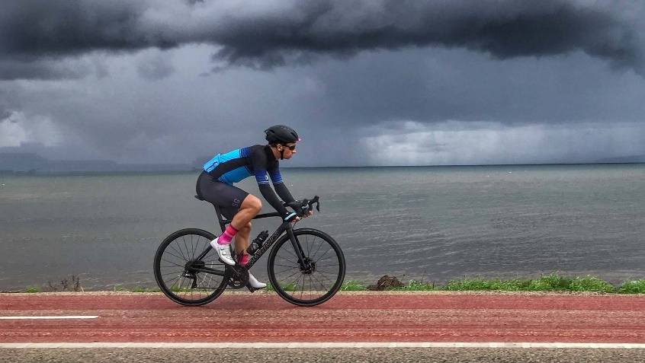

**Cyclist, 80% Confident**

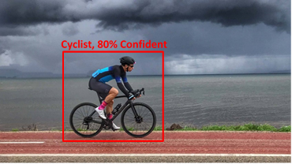Given an outdoor image frame, detect bicyclists and all the other objects in view.

* Detection of bicyclist should localize its position with respect to the image frame
* Draw a bounding box in the output image frame with a label classification confidence score.

We measure the confidence score in percentage for classification and evaluate object detection performance using AP (Average Precision) metric

# 2. Analysis

## A. Data Exploration

**Figure:** Annotated or labeled images for objects in MS COCO dataset

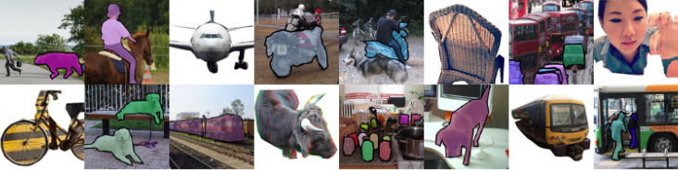

We will use a sampled version of the MS COCO dataset ([https://cocodataset.org](https://cocodataset.org/)) since our storage and compute needs are to be kept low.

COCO is a large-scale object detection, segmentation, and captioning dataset. COCO has several features. However, we will use the object instance detection from its annotated  1.5 million object instances with 80 classes and median image ratio is 640x480.

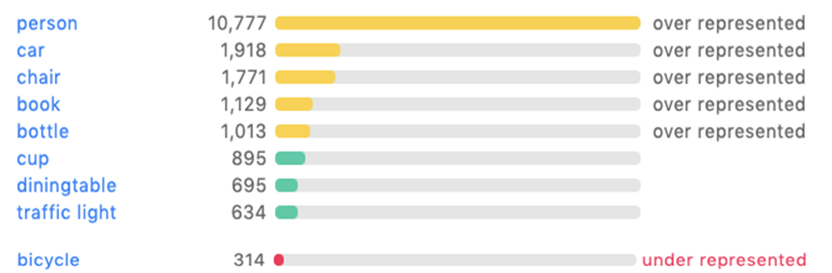

**Figure:** Typical objects annotation distribution in the dataset (low bicycle count), above is the explore webpage for MS COCO annotation label based search functionality.

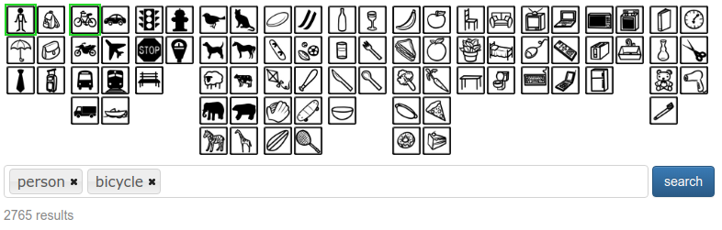

In the figure above, we can see the various label distributions and representation in the entire dataset. An explore functionality in the webpage (<https://cocodataset.org/#explore>) or pycocotools dataset API is used for this purpose.

We use MS COCO dataset explorer to visualize the existing data and visually understand the distribution by searching for a particular annotation label like “person” or “bicycle”. There are about 2765 images in train & validation set which contains both these labels.

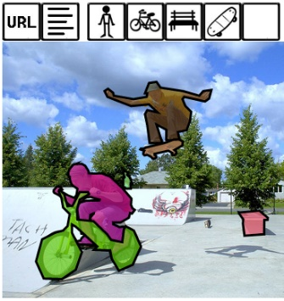We will describe the annotated dataset. The data itself has various categories in annotation and “category_id” labels one of the bounding boxes for an image.

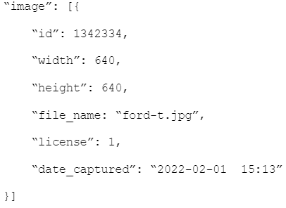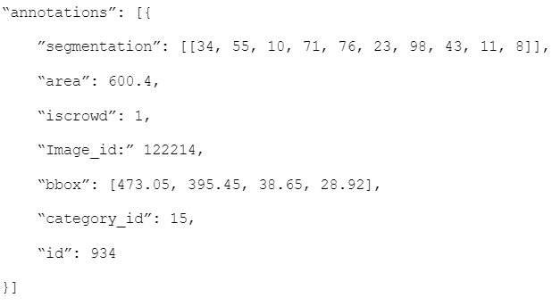

**Figure:** JSON format for raw image metadata and corresponding annotations with label & position

Let us look at one of the images that contains bicycle and person labels in the MS COCO dataset explore web page. We will use these annotations to create a sampled dataset to learn person and bicycle classes. In our model building we want to learn a new class “cyclist” in the super category person. Next section will describe the sampling strategy and updates to the annotation.

## B. Data Sampling & Visualization

To detect cyclist in an image we use a computer vision task called object detection. There is no dataset available specifically for this outcome. Hence, we use the MS COCO dataset and sample the images where we observe people with bicycles and annotate them as cyclist. We will see a sampling approach in the dataset that makes use of IoU (Intersection over Union) approach to find overlap in the annotations and assign a label to person, categorizing them as cyclist.

There are about 2643 images in train & 122 in validation set which contains person and bicycle labels. We use the below workflow to create our label of interest.

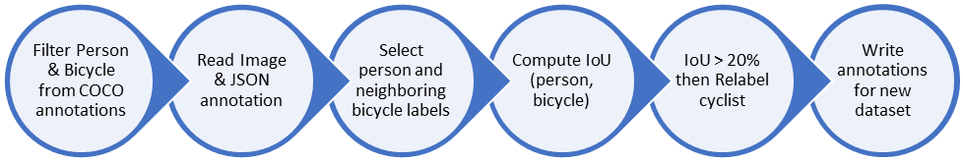

**Figure:** Workflow for processing the dataset and updating the label as cyclist.

Deep learning model will read training data files with these annotation labels and bounding box during the training phase and then later in the evaluation phase we understand the models overfitness to the data and do model selection.

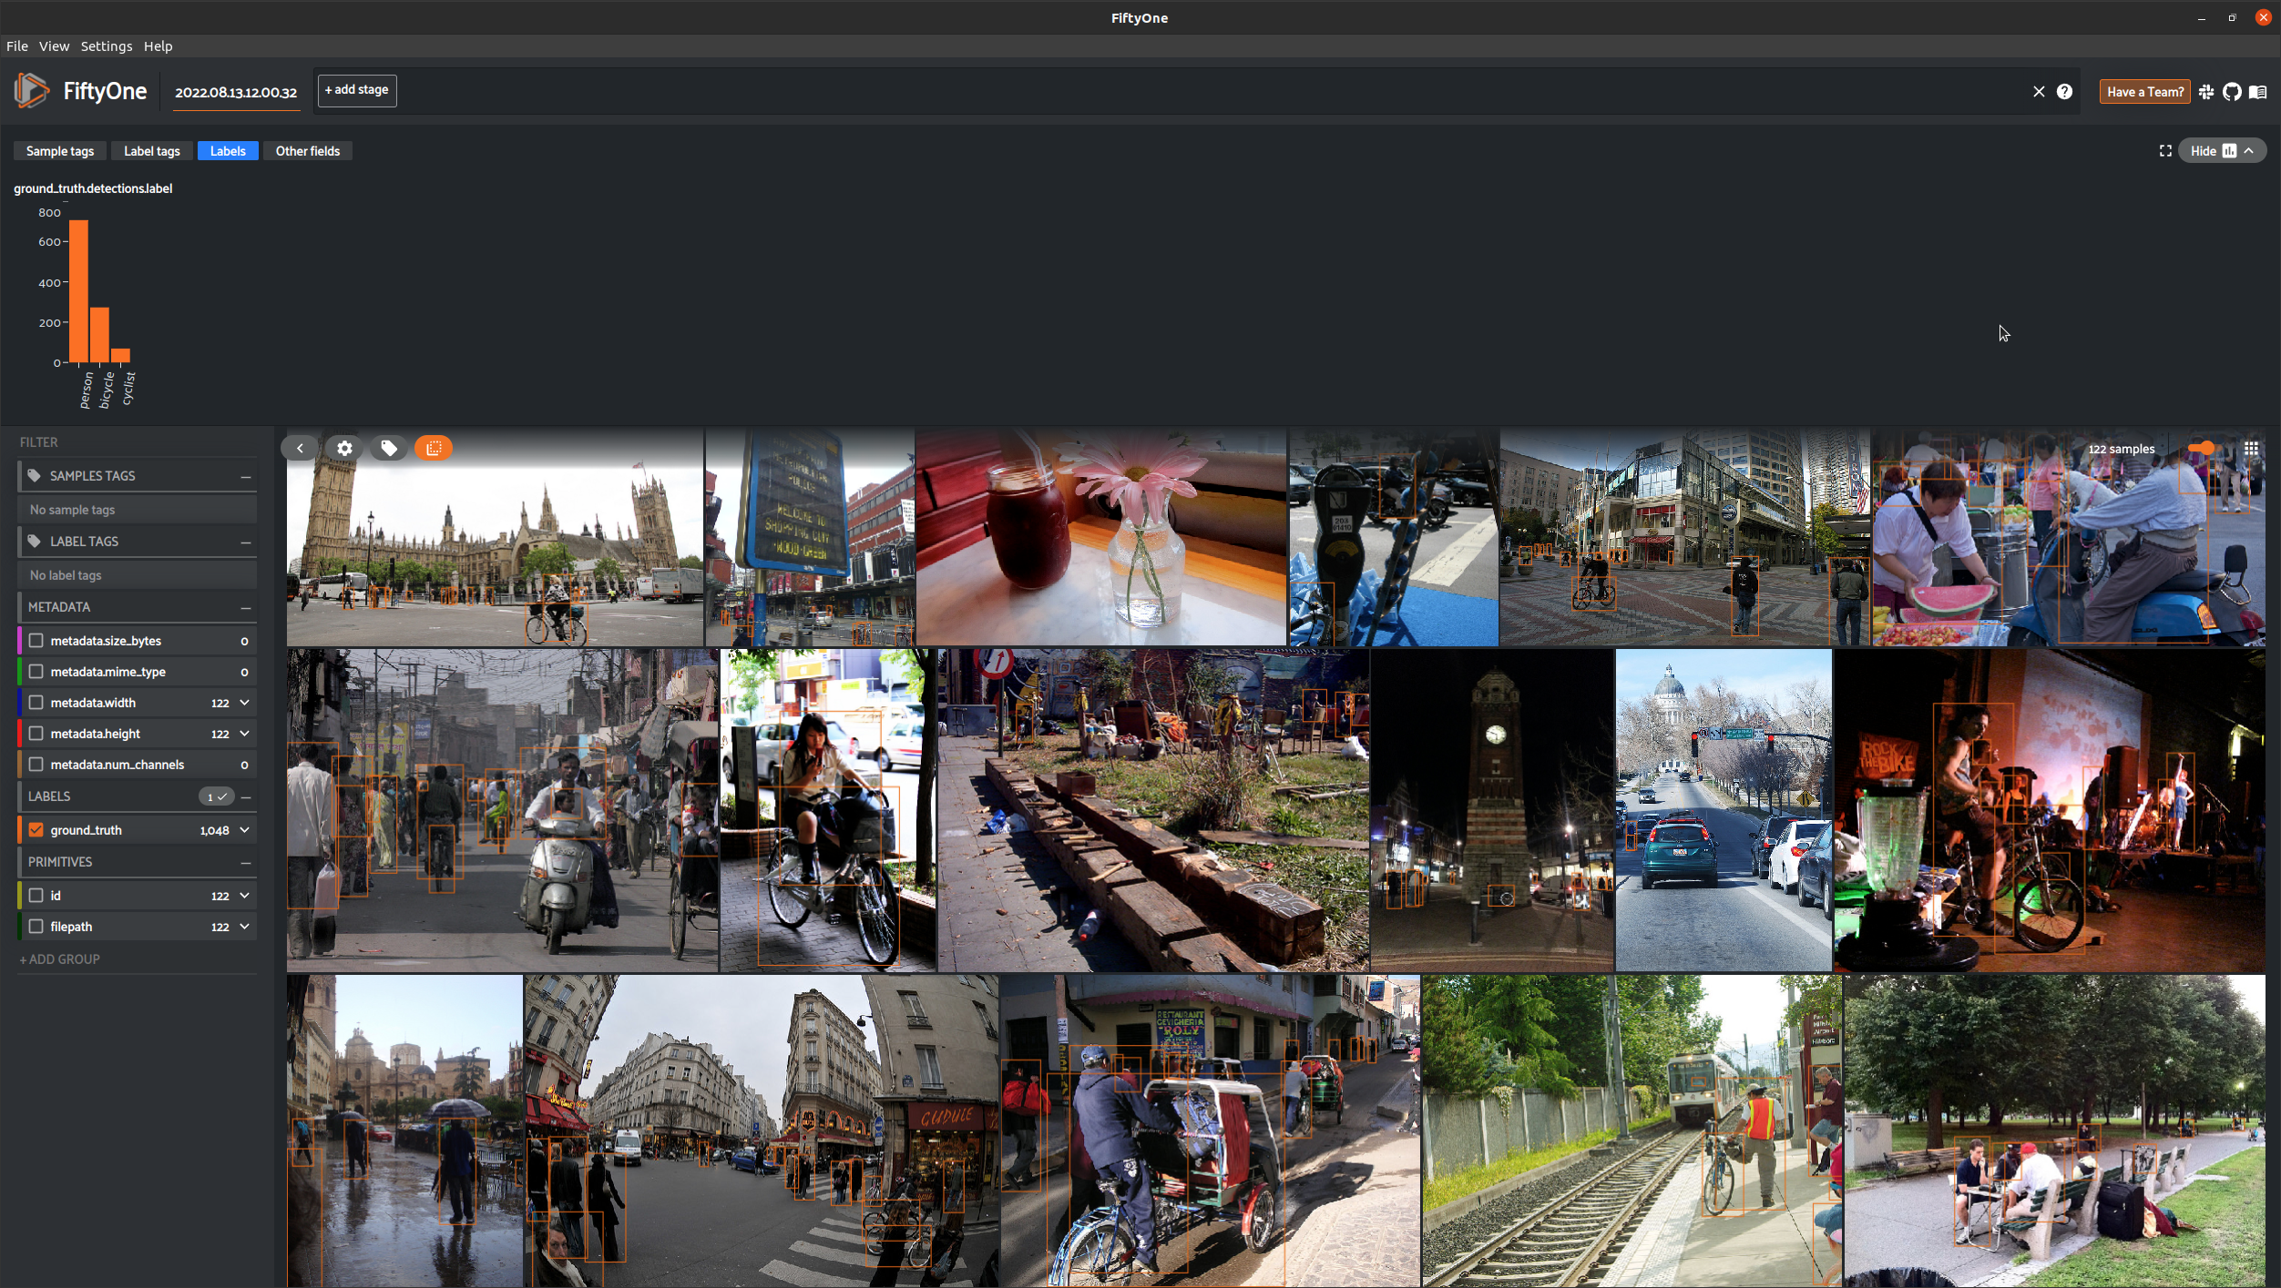

**Figure:** Visualize the labels in FiftyOne. There are 706 person, 273 bicycle and 69 cyclist labels in the created annotations for the object detection task.

To visualize the new updated dataset, we use an open sourced tool FiftyOne from Voxel51 (<https://voxel51.com/docs/fiftyone/index.html>).

This procedure is covered in the sampling notebook at <https://github.com/karmarv/udacity-aws-sagemaker-capstone/blob/main/samples/coco_sampler.ipynb>

## C. Algorithms & Techniques

Object detection is the computer vision based approach to classify and localize objects in an image. We use the dataset generated above to supervise and train a Deep learning based model to detect cyclist in an image.

Current object detectors can be divided into two categories: Networks separating the tasks of determining the location of objects and their classification, where Faster R-CNN is one of the most famous ones, and networks which predict bounding boxes and class scores at once, with the YOLO and SSD networks being famous architectures.

We would like to approach by using a Yolo based approach to detect objects in the given image. It predicts the bounding boxes and classes for the whole image in one run of the algorithm, instead of selecting the inserting parts only. In YOLO, the architecture splits the input image into m x m grid, and then further each grid generates 2 bounding boxes and the class probabilities of those bounding boxes.

***Advantages:***

* Faster Speed
* It is a highly generalized network
* It processes each frame at the rate of 45 fps for a larger network and 150 fps for a smaller network and near real-time.

***Disadvantages:***

* It is very difficult to detect small objects from the image.
* It is very difficult to detect objects which are very close to each other because of the grid.
* It has comparatively more localization and low recall error compared to faster RCNN.

### **Yolo**

The YOLO algorithm was first introduced in 2015 to solve the object detection problem. As the name suggests, the object detection problem is when a computer is given an image and has to detect where certain objects in that image are.

**Figure**: Input is 448×448×3 tensor representing the RGB values. output is a 7×7×30 tensor with grid size S=7.

For each grid cell model predicts B bounding boxes, confidence for those boxes, and C class probabilities. These predictions are encoded as an S × S × (B ∗ 5 + C) tensor.

This simplified structure allows for a simple output layer enabling high processing throughput in FPS.

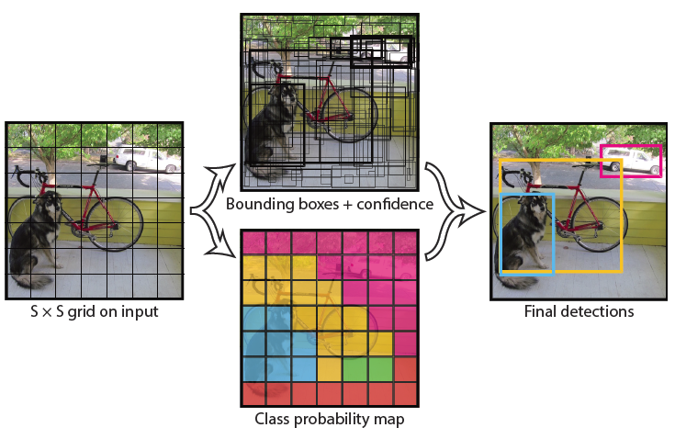

The YOLO algorithm works by predicting three different features: (a.) **Bounding box**: (25, 5, 185, 183), (b.) **Confidence**: 0.9567, (c.) **Class**: cyclist. The bounding box represent the location of the object in the image and confidence is the probabilistic score of the classification. The YOLOv1 algorithm takes the image as input and outputs a tensor that can be broken up into the three properties of a bounding box: location, confidence, and class.

### **YoloX**

The YOLOX uses a Darknet-53 backbone ( FPN or Feature Pyramid Network) to learn features like YoloV3. The FPN extracts information at a different scale. As the number of channels increases, the length and width of the image decreases. So, the 256 channel transition output extract features at a smaller scale while the 1024 channel output extracts features at a larger scale since the 1024 channel output has less information from the original image to work with. The major difference between YoloV3 and YoloX is in the head. We will discuss that in the architecture or implementation section.

## D. Benchmark

We look at the various benchmarks reported for YOLOX in terms of mAP (mean Average Precision) which is precision score averaged over IoU (0.5 to 0.95 in steps of 0.05).

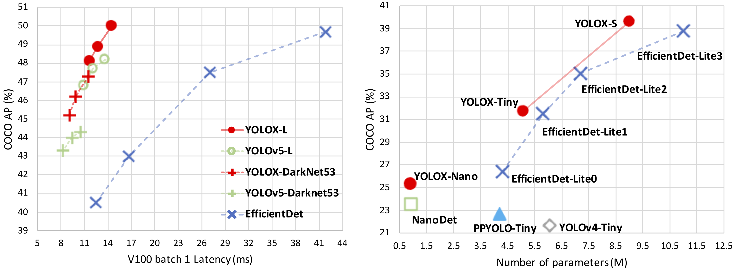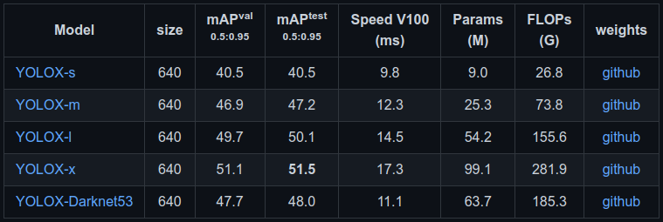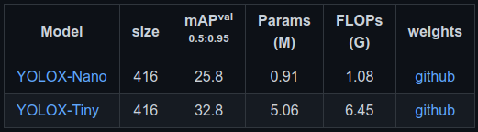

**Figure:** (above) Comparative benchmark for the latency and number of parameters in the model. (below) table represents the mAP metric for various model size evaluated on MS COCO dataset.

In our evaluations, we would like to use the YoloX nano and small variant for our evaluation considering the low computational requirements of these models.

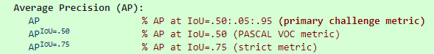Average precision is the metric used to evaluate COCO dataset and it related with how accurately and object is detected by the object detection model inference step.

# 3. Methodology

## A. Preprocessing

The dataset contains 706 person, 273 bicycle and 69 cyclist labels in the sampled/updated annotations for the object detection task. This step sets the dataset to be loaded with simple augmentation like flip, rotate and also includes the mosaic augmentation approach. The mosaic augmentation combines multiple images into a single image like a collage and also maintains the bounding box labelled in the new image. This has shown to perform well on many benchmarks and is also proved in the YoloV4 and YoloV5 papers.

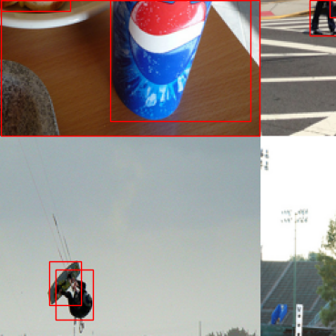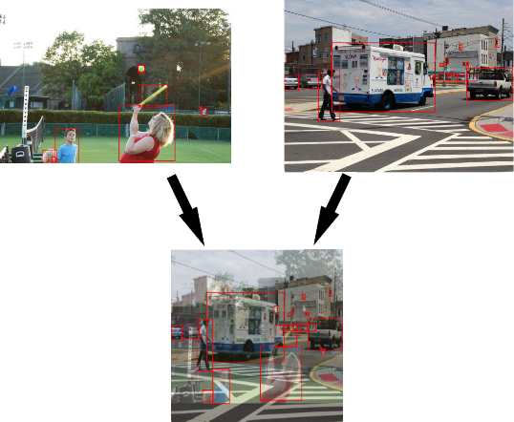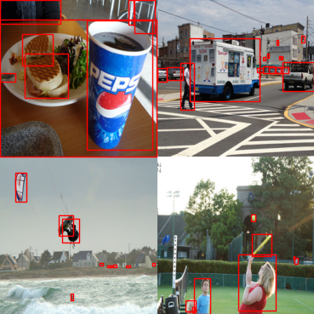

**Figure:** Strategies for Mosaic and MixUp augmentations in YoloX or YoloV4 model setup

## B. Implementation

Architecture and use of YOLOX based model

The input into both the YOLOv3 head and the YOLOX head is the 3 outputs from the FPN (darknet) backbone at three different scales — 1024, 512, 256 channels.

The output of the two heads is essentially the exact same with dimensions (H×W×features) which is just like the original YOLO. The difference between the two heads is that YOLOv3 uses a coupled head and YOLOX uses a decoupled head. So, the output of YOLOX is actually 3 tensors each holding different information instead of 1 massive tensor with all information.

The three tensors YOLOX outputs hold the same information as the massive tensor YOLOv3 outputs:

1. Cls: The class of each bounding box
2. Reg: The 4 parts to the bounding box (x, y, w, h)
3. IoU (Obj): For some reason, the authors use IoU instead of Obj, but this output is just how confident is the network that there’s an object in the bounding box (objectness)

**Figure:** YOLOv3 vs. YOLOX head from the paper: https://paperswithcode.com/method/yolox

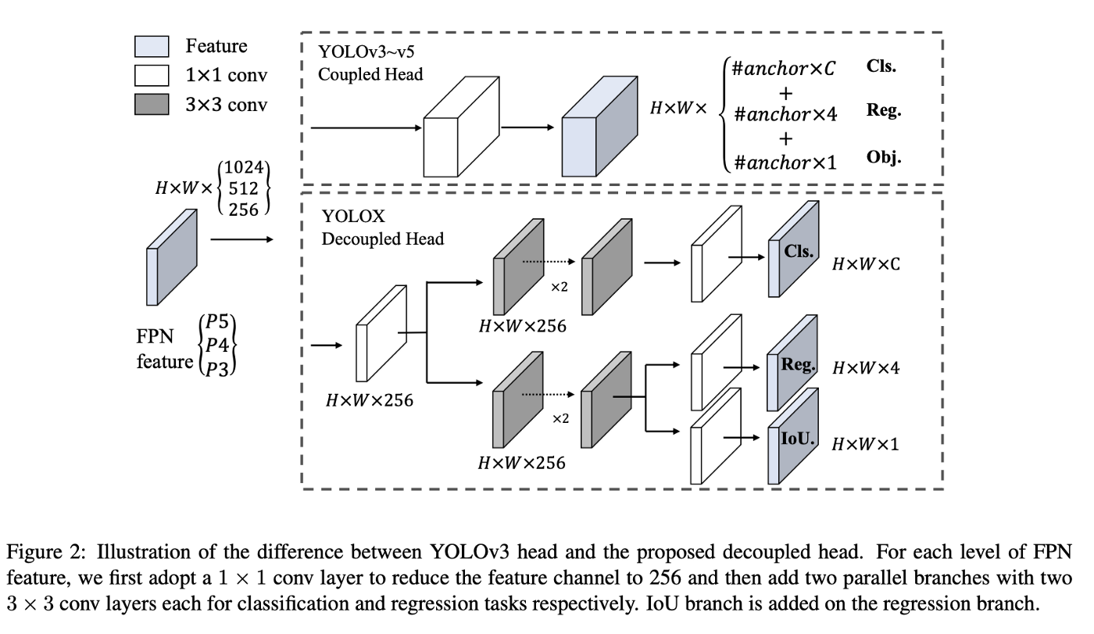

Just like with the original output, each “pixel” in the height and width of the output is a different bounding box prediction. So, there are H*W different predictions.

The outputs listed above are only for a single output in the FPN. Remember there are three outputs from the FPN which are fed into the heads of YOLOv3 and YOLOX. This means there are actually three different outputs from each of the heads instead of 1. So, the output of YOLOv3 is actually (3×H×W×features) and the output of YOLOX is actually 3 of each of the Cls, Reg, and IoU (obj) outputs making 9 totals outputs.

## C. Refinement

We run experiments and tune the model w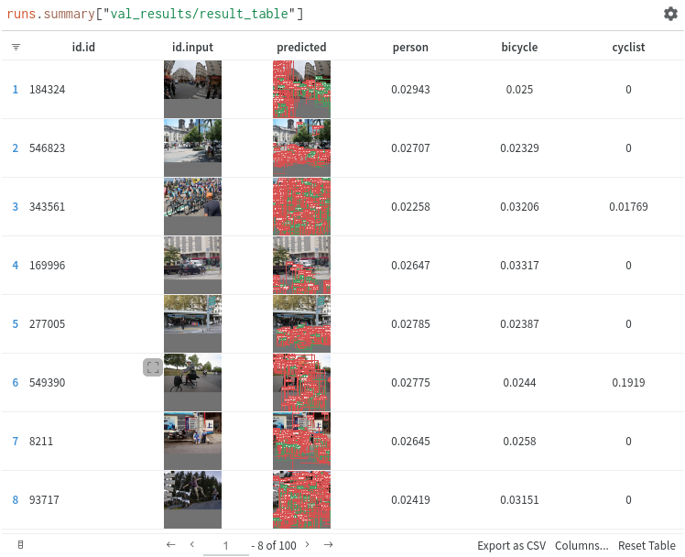ith batch 8, 16, 32 etc

The observed results on yolox_nano

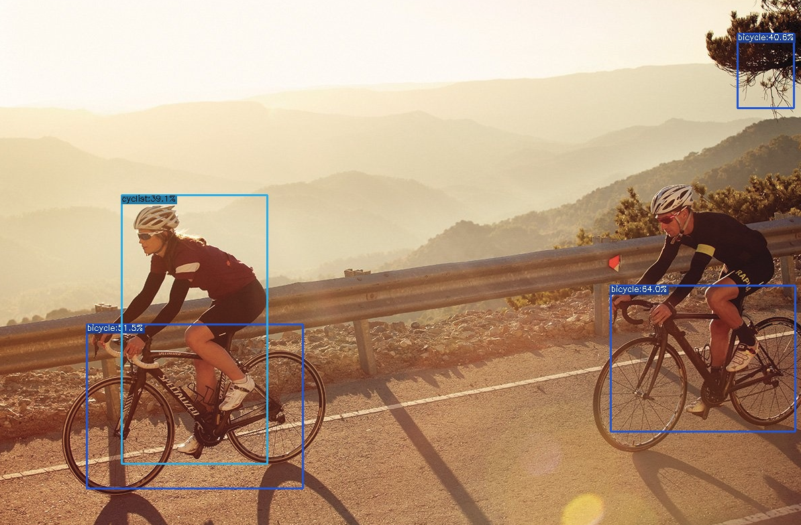

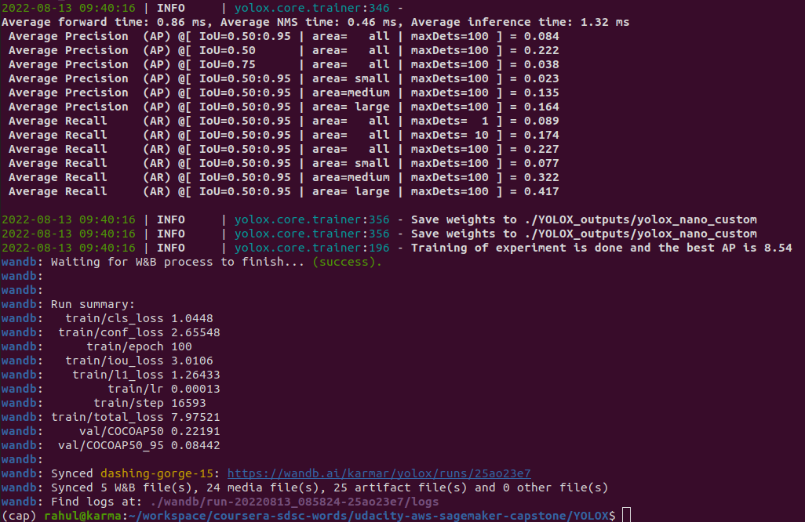

The observed results on yolox_small

# 4. Results

## A. Model Evaluation and Validation

We preprocess the dataset

## B. Justification

We

The solution code should be able to run as a python inference file on an EC2 instance or can be called from a lambda function as an endpoint. We will use the EC2 instance approach and output the image file with labels.

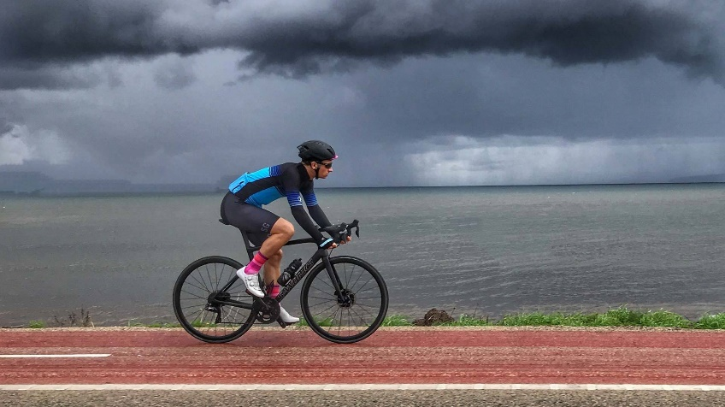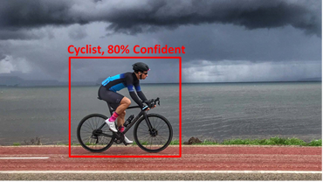

Object Detection Deep Learning Inference Model

Faster R-CNN or Yolo

Model Training Objective Data Augmentation



**Figure:** Input image on the left and output image with object detection results on the right

* **Step 1**: We will use multiple training images with object position annotation to architect a deep learning object detection model
* **Step 2**: We train the deep learning model with augmented dataset with objective that minimizes the loss between predicted bounding box label and actual ground truth bounding box label
* **Step 3**: We select the model that optimizes the loss function
* **Step 4**: We setup the model for inference and demonstrate the output results

Intend to use AWS Sagemaker JupyterLab instance to develop this solution and attempt to deploy this as an endpoint.

# 4. Datasets & Inputs

We will use a sampled version of the MS COCO dataset ([https://cocodataset.org](https://cocodataset.org/)) since our storage and compute needs are to be kept low.

deep learning model will read training data files with these annotation labels and bounding box during the training phase and then later in the evaluation phase we understand the models overfitness to the data and do model selection.

# 5. Benchmark Model

**Figure:** Model Comparison (YoloV4 - )

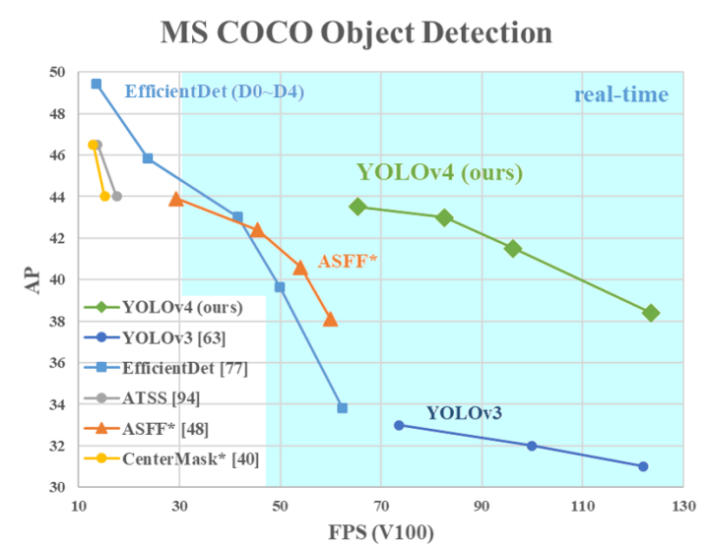

Details on how typical object detectors are setup is mentioned in the figure above and for a small model size and low latency we can choose a Yolo based approach to detect bicyclists in the image.

# 6. Evalutation Metrics

Detection Evaluation *metrics* used by COCO as per their web page is linked here (<https://cocodataset.org/#detection-eval>)

We will be using the Average Precision metric to specify the benchmark or characterizing the performance of the object detector model on COCO.



1. AP is averaged over all categories. Traditionally, this is called "mean average precision" (mAP). No distinction between AP and mAP (and likewise AR and mAR) and assume the difference is clear from context.
2. AP (averaged across all 10 IoU thresholds and all 80 categories) will determine the best score.
3. AP is averaged over multiple Intersection over Union (IoU) values.

We can use MS COCO codebase (<https://github.com/cocodataset/cocoapi>) for loading images and evaluating based on this dataset.

# 7. Theoretical Workflow

There are three major steps in the DNN based object detection. We describe the workflow in-order of steps to be performed:

1. **Dataset Pre-processing and Model architecture**

* Dataset setup with images sampled for annotated bicycle labels
* Split of training/evaluation/test dataset for selected samples. (Typically, 80:10:10). We will use this for object detection model training with the training and evaluation dataset.
* Common object detectors have the following component (shown in benchmark model figure 2 and in Yolov4 paper)
  + Input image augmented or sized to 640x480
  + Backbone like Resnet 18 or larger
  + Prediction Neck/Head focused on objectives like regression, classification for loss based optimization
  + As per Yolo we have three partial categories losses: confidence/log loss, location/regression loss, category/class loss

1. **Yolo v4 (One of the yolo variants) model training objective** 
   * Theoretically described in terms of a loss function as below
   * 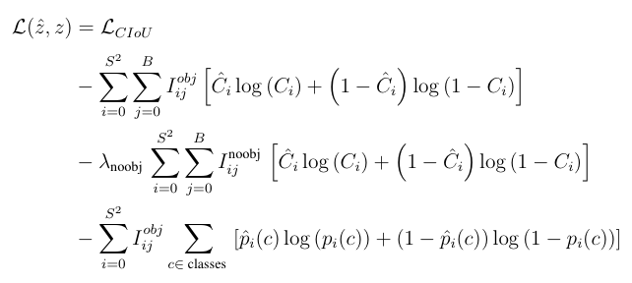
   * **CIoU Loss** instead of MSE for the regression terms (x,y,w,h). CIoU stands for Complete Intersection over Union, and is not so far from the MSE loss. It proposes to compare width and height a bit more interestingly (consistency between aspect ratios), but it keeps the MSE for the comparison between bounding box centers. This is the first term in the equation above.
   * **Box-per-cell level prediction** instead of cell level prediction for the class probabilities, so a slightly different penalization for the classification terms. where ***Iobji*** denotes if object appears in cell ***i*** and ***Iobjij*** denotes that the ***jth*** bounding box predictor in cell ***i*** is “responsible” for that prediction
   * **Binary cross entropy** for the objectness and classification scores across all classes. This is the last term in the loss function expansion.
2. **Model Inference**

* The DNN model is set to eval mode and weights are frozen
* Given a new image, the model will use the model weights to output a array of the size of class identifier and (x,y,w,h) attributes for multiple detected labels.
* We use this information to overlay bounding box on the image using OpenCV and present the results.

In general, we will use a PyTorch based object detector model from open source projects. This will help provide a verifiable evaluation on a standard CPU/GPU training machine.